A000-ME-Neo Elamite-Two Ibex and Tree of Life-Ram in Thicket-675-725 BCE

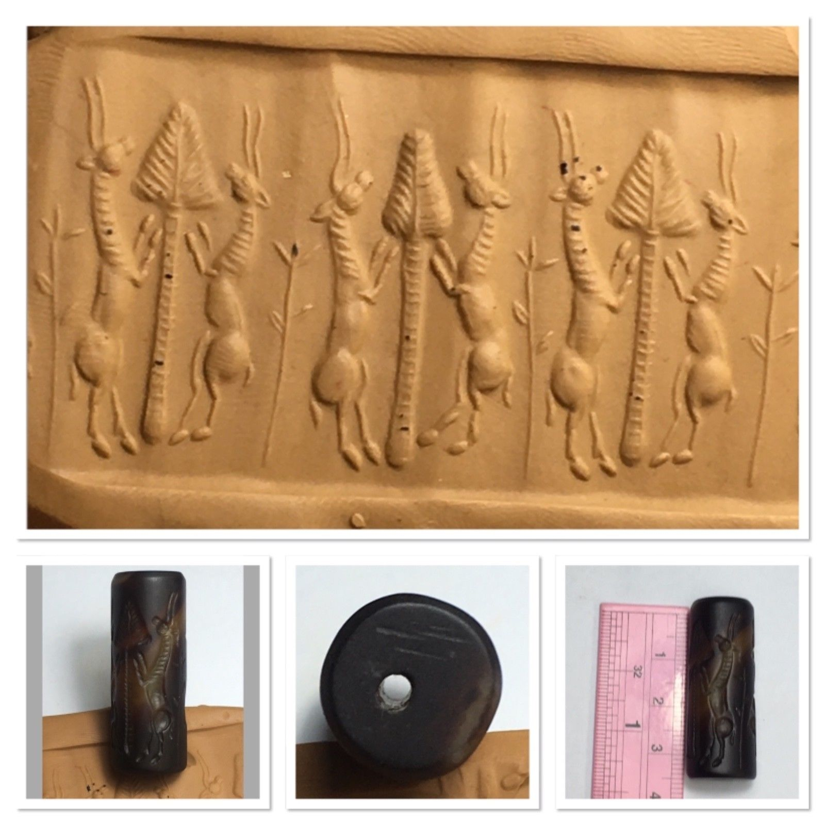

**Case no.: Cylinder Seals**

**Accession Number:**

**Formal Label:** ME-Neo Elamite-Two Ibex and Tree of Life-Ram in Thicket-675-725 BCE

**Display Description:**

The Elamites were a people located in southwestern Iran, in what is now [Khuzestan](https://en.wikipedia.org/wiki/Khuzestan), [Ilam](https://en.wikipedia.org/wiki/%C4%AAl%C4%81m_Province), [Fars](https://en.wikipedia.org/wiki/Fars_Province), [Bushehr](https://en.wikipedia.org/wiki/Bushehr_Province), [Lorestan](https://en.wikipedia.org/wiki/Lorest%C4%81n_Province), [Bakhtiari](https://en.wikipedia.org/wiki/Chaharmahal_and_Bakhtiari_Province) and [Kohgiluyeh](https://en.wikipedia.org/wiki/Kohgiluyeh_and_Boyer-Ahmad_Province) provinces. Their language was neither [Semitic](https://en.wikipedia.org/wiki/Semitic_languages) nor [Indo-European](https://en.wikipedia.org/wiki/Indo-European_languages), and they were the geographic precursors of the Persian/Median empire that later appeared. In Mesopotamia and Iran, the ibex have thick horns, which sweep back in a saber-like curve, and are flattened underneath; the upper surface is ornamented by a number of protuberances inclined backward and extending across the whole width of the upper surface, like ribs (Harrington 1977).

**LC Classification:**

**Date or Time Horizon:** 675-725 BCE, during reign of Humban-Kitin, King of Susa, last quarter of 7th century, son of Shutur-Nahhunte III. After https://en.wikipedia.org/wiki/List_of_rulers_of_Elam

**Geographical Area:** Susa

**Map:**

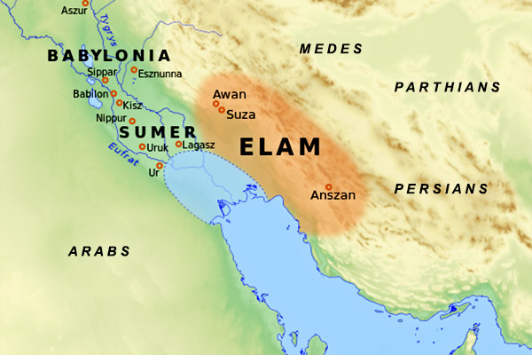

**After https://pp.userapi.com/c845216/v845216156/e14b7/NMvmTHMrsSc.jpg**

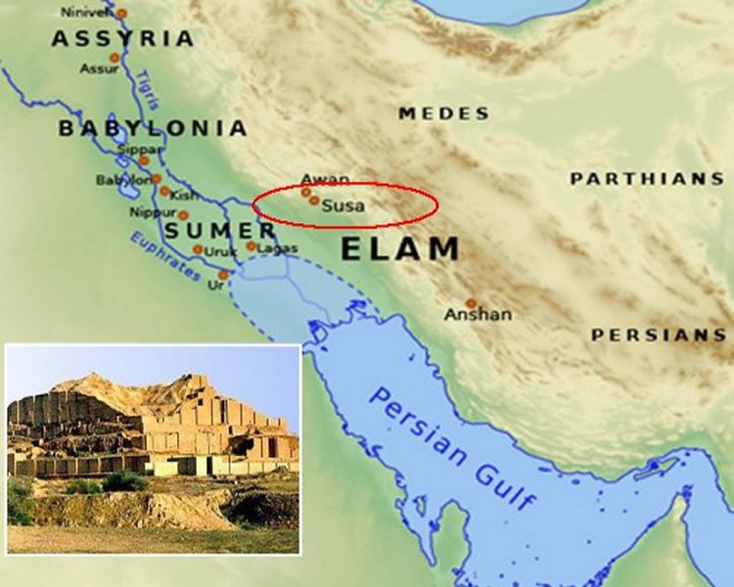

**After http://www.ancientpages.com/wp-content/uploads/2017/05/susamap.jpg**

**GPS coordinates:**

**Cultural Affiliation:**

**Media:** **Dimensions:**

**Weight:**

**Condition:**

**Provenance:**

**Discussion:**

Elam is a historical region and an ancient state (third millennium - middle of the 6th century BCE), located in the southwest of modern Iran (Khuzestan and Lurestan provinces).The Elamites themselves wrote (V. Hinz, "The State of Elam") the name of their country with the cuniform "hal-ta-am-ti", which perhaps should be expressed by "hal-tampt", and "hal" means "country", and "tampt" means "lord." Thus, the Elamites perceived their homeland as “the country of the Lord. It is also believed (D.T. Potts, "The Archeology of Elam") that the term "Elam" is an artificial construction, the name was coined by Mesopotamian scribes, who looked from their river alluvial valleys to the Iranian Plateau. In the Sumerian sources of the middle of the third millennium BCE, the name Elam was written by the NIM sumerogram, the value of which was simply “high”, it was often accompanied by the defining designation KI “land, country”. In the Akkadian form, the KUR elammatum or “land of Elam” was used, as a rule. However, it should be noted that the original name of Elam did not apply to the whole country. The country had a number of areas that in the early period retained their political independence: Avan, Adamdun, Anshan, Varakhse, Simashka, Susa, etc. The names of some areas often appeared in the titles of the Elam kings. All these areas from the end of III millennium BCE were united under the auspices of Elam.

In the lower Mesopotamian river valley the eighth to the sixth centuries BCE were exemplified by incessant conflicts created by the incessant ambitions of Assurbanipal to control the Elamites, which reached its climax during the second half of the seventh century BCE, the probable date of this cylinder seal.

In 653 BCE Assurbanipal advanced beyond the border town of Der, confronted the Elamites at the Ulai River and killed the Elamite king Teumman (Tepti-Humpan-Inshushinak, 663–653 BCE). Then Assurbanipal installed a suzerainty with the pro-Assyrian Humpan-nikash II (Huban-nugash) as king of Elam and his brother Attamet (Atta-hameti-Inshushinak) as Susa’s viceroy. Assurbanipal created the city of Hidalu as a kingdom for a third brother, Tammaritu II. Then, in the next year Assurbanipal was challenged by his brother Shamash-shum-ukin [(](http://www.cais-soas.com/CAIS/Art/Decorative-Arts/arjan_bowl.htm#_ftn5)Brinkman 1984: 93-104; Waters 1999: 99-107; Waters 2000; Russell 1999). Seeing this wedge in Assurbanipal’s power the Elamite king Huban-nugash broke his oath of alliance and sided with Shamash-shum-ukin. Another anti-Assurbanipal alliance was made in Hidalu between Huban-nugash, his brother Tammaritu II, and the people of the land of Parsuash. Assurbanipal, challenged on all sides, waged a brutal war and defeated the Elamite king Kurash (Cyrus), son of Teispes, who was forced to surrender his son Arukku as hostage to Assurbanipal. Assurbanipal was still not in total control of Elam; so in 646 BCE he sent his army to lay siege to the city of Madaktu (Mirochedji 1985: 215), to ravage Susa and thereby to fragment Elam into three disempowered suzerainties of Susa, Madaktu (Potts 1999: 13-28) and Hidalu (Boucharlat 1994: 220).

The two ibexes on this seal that are confronting each other before the tree of life suggests that this seal was an emblem of the aspirations of Elamites to establish a union in order to confront Assurbanipal.

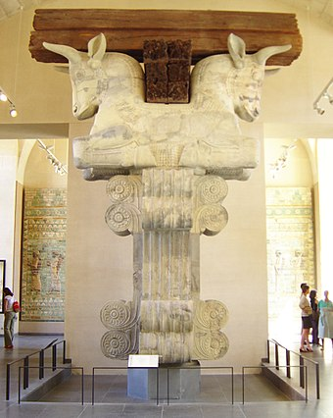

Column showing two reclining bulls in opposition from the Apadana of the Susa Palace during the reign of Darius I in the Louvre after[***https://pp.userapi.com/c845216/v845216876/e3f8e/yilGYMGot4U.jpg***](https://pp.userapi.com/c845216/v845216876/e3f8e/yilGYMGot4U.jpg)

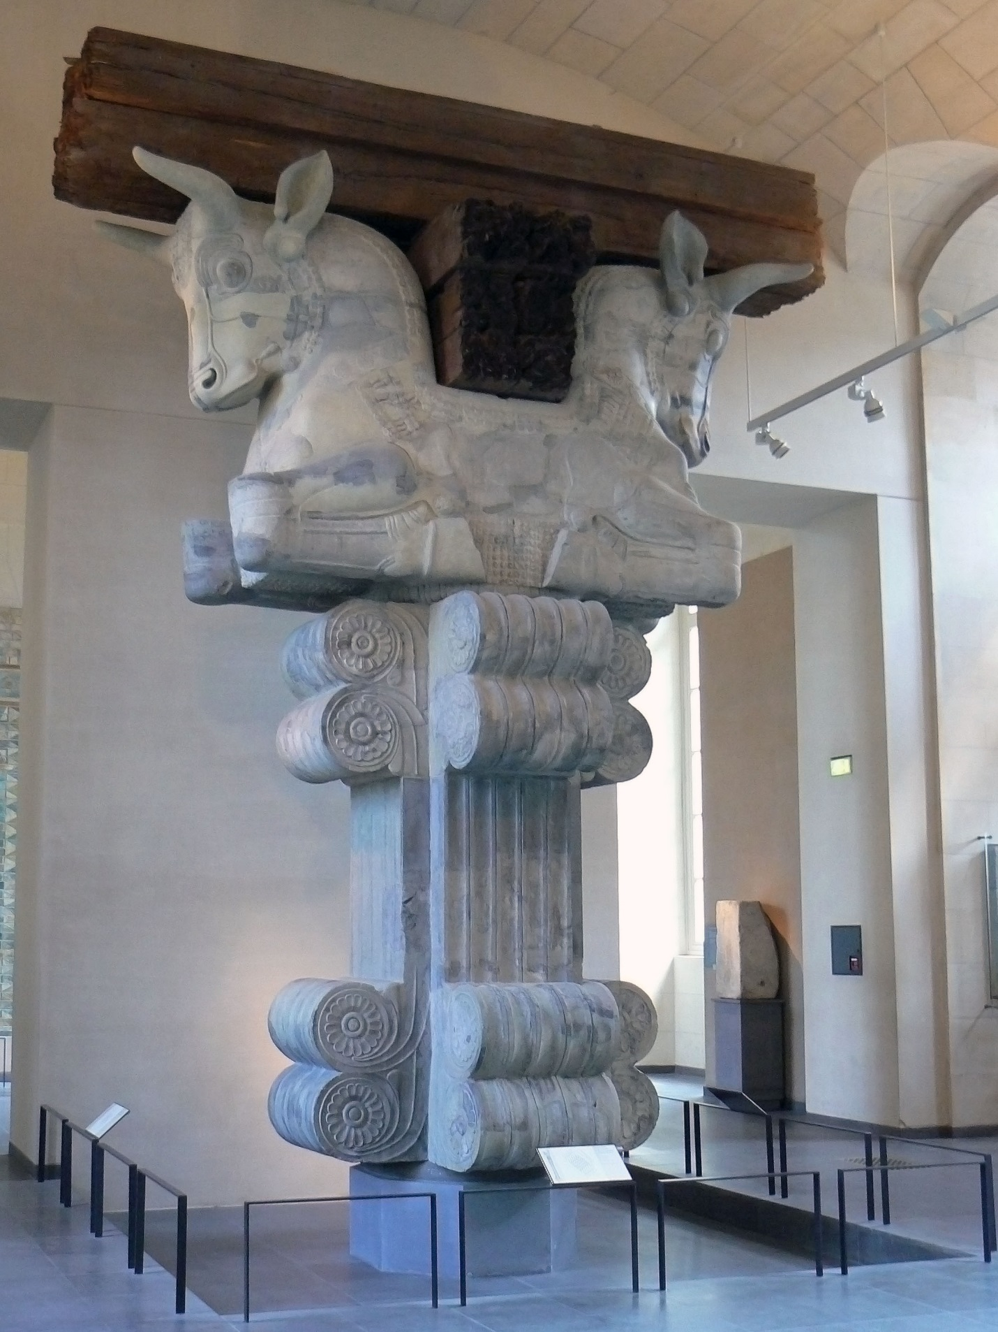

Column showing two reclining bulls in opposition from the Apadana of the Susa Palace during the reign of Darius I in the Louvre afterhttps://upload.wikimedia.org/wikipedia/commons/d/de/Bull_capital_Apadana_%286%29.jpg

**References:**

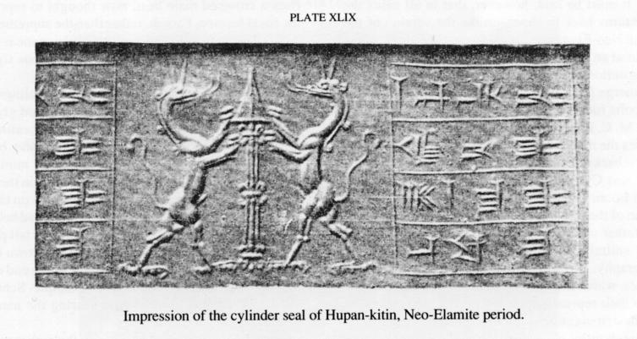

References

|  |
| --- |
| AMIET, P. 1992. Tiares Elamites. Studi Micenei ed Egeo-Anatolici XXX, pp. 257-265. |
|  |  |
| AMIET, P. 1973. La Glyptique de la Fin de l’Elam. Arts Asiatiques 28. |  |
| AMIET, P. 1966. Elam. Auvers sur l’Oise. |  |
| BEESTON, A.F.L. 1972. The Ritual Hunt, a Study in Old South Arabian Religious Practice," Le Muséon 61: 183-196. |  |
| BLACK, J. and GREEN, A. 1992. Gods, Demons and Symbols of Ancient Mesopotamia (University of Texas Press). |  |
| BORCHHARDT, J. 1972. Homerische Helme. Mainz: Von Zabern. |  |
| BOUCHARLAT, R. 1994. Continuites ل Suse au Ier Millenaire B.C. Achaemenid History VIII. |  |
| BRIANT, P. 1989. La Perse Avant l'Empire (un Etat de la Question). Iranica Antiqua XIX. |  |
| BRIANT, P. 1982. Etats et Pasteurs au Moyen-Orient Ancient (Cambridge University Press). |  |
| BRINKMAN, J.A. 1984. Prelude to Empire: Babylonian Society and Politics, 747-626 B.C. Philadelphia, pp. 93-104. |  |
| CAMERON, G. G. 1936.History of Early Iran. Chicago: University of Chicago Press. |  |
| CAQUOT, A.1974. Textes Ougaritiques. Tome I. Paris: Editions du Cerf.. |  |
| CARTER, E. 1984. Bridging the Gap Between the Elamites and the Persians in Southeastern Khuzistan, Achaemenid History VIII, pp.65-77. |  |
| CIRLOT, J. E. 1971. A Dictionary of Symbols. New York: Dorset Press. |  |
| CLAESSEN, H. J. M. 1996. Ideology and the Formation of Early States. Leyden: Brill. |  |
| CURTIS, J. E. and READE, J. E. 1996. Art and Empire. Metropolitan Museum of Art. |  |

|  |  |
| --- | --- |
|  | CURTIS, J. E. 1995. Later Mesopotamia and Iran: Tribes and Empires 1600-639 B.C. British Museum Press. |
|  | DANTHINE, H. 1973. Le Palmier-Dattier et les Arbres Sacres dans L’Iconographie de l’AsieOccidentale Ancienne. Paris. |
|  | DE MAIGRET, A. and ROBIN, C-J. 1989. Les Fouilles Italiennes de Yala (Yemen du Nord): Nouvelles Données sur la Chronologie de l'Arabie du Sud PréIslamique.Academie des Inscriptions and Belles-Lettres Comptes Rendus, pp. 255-291. |
|  | DE MORGAN, J. 1905. Découverte d’une Sépulture Achémenide ل Suse,” Mémoires de la Delegation en Perse 9. |
|  | DE WAELE, E. 1989. Musicians and Musical Instruments on the Rock Reliefs in the Elamite Sanctuary of Kul-e Farah (Izeh),” Iran, pp. 29-33. |
|  | DELAPORTE, L. 1920. Catalogue Des Cilindres Orientaux II, plate 94 (5), A.836; |
|  | DEUTCH, R. AND HELTZER, M. 1994. Forty Ancient Semitic Inscriptions. Archaeological Center Publication (Tel Aviv-Jaffa, Israel), pp. 69–89. |
|  | DITTMANN, R. 1984. Eine Randebene des Zagros in der Frühzeit (Berliner Beitrنge zum Vorderen Orient Band 3, Berlin). |
|  | DUCHESNE-GUILLEMIN, J. 1986. La Location de Huhnur. Fragmenta Historiae Elamicae, Paris. |
|  | DURHAM, S. 1985. The Monkey in the Middle. ZA, band 75. |
|  | FAEGRE, T. 1979. Tents: Architecture of the Nomads. New York: Anchor Books. |
|  | FELDMAN, M. H. 2002. Luxurious Forms: Redefining a Mediterranean ‘International Style,’ 1400-1200 b.c.e. The Art Bulletin, vol. LXXXIV/1. |
|  | FRYE, R. N. 1972. Gestures of Deference to Royalty in Ancient Iran. Iranica Antiqua 9. GEORGE, A. 1999. The Epic of Gilgamesh. Barnes and Noble. |
|  | GREEN, A. 1994. Mischwesen, Reallexikon der Assyriologie. |
|  | GUNTER, A. 1982. Representation of Urartian and Western Iranian Fortress Architecture in the Assyrian Reliefs. Iran XX. |
|  | HAMILTON, R. W. 1966.A Silver Bowl in the Ashmolean Museum. Iraq 28, pp. 1-17. |
|  | HANSMAN, J. 1974. Elamites, Achaemenians and Anshan, Iran 12. |
|  | HARTNER, W. 1965. The Earliest History of the Constellations in the Near East and the Motif of the Lion-Bull Combat. of Near Eastern Studies XXIV, pp. 1-18. |
|  | HARRINGTON, F. 1977. A Guide to Mammals of Iran. Department of the Environment, Tehran, Iran. |
|  | HINZ, W. 1975. Reallexikon der Assyriologie vol. 4. |
|  | HOLE, F., FLANERY, K. V. and NEELY, J.A. 1969. Prehistory and Human Ecology of the Deh Luran Plain. Ann Arbor, Michigan. |
|  | HOROWITZ, W. 1988. A Babylonian Map of the World. Iraq 50. |
|  | KANTOR, H. J. 1966. Landscape in Akkadian Art. Journal of Near Eastern Studies XXV, pp 145-155. |
|  | KAPTAN, D. 1966. The Great King’s Audience. Fremde Zeiten. Edtrs. E. Blakolmer, K.R. Krierer, and various. Wien: Phobos Verlag, Wien. |
|  | KILMER, A. D. 1985. Music and Dance in Ancient Western Asia. Visual and Performing Arts. CANE vol. III. |
|  | KRAELING, C.H. 1957. Narration in Ancient Art. AJA 61. |
|  | LION, B. 1992. La Circulation des Animaux Exotiques au Proche-Orient Antique. In La Circulation des biens, des personnes, et des idees dans le Proche Orient ancient. Rencontre Assyriologique Internationale. ERC. |
|  | LIPINSKI, E. 1995. Dieux et Deesses de l’Univers Phenicien et Punique. Orientalia Lovaniensia Analecta 64. |
|  | LUCKENBILL, D. 1927. Ancient Records of Assyria and Babylonia 1926-27 ( II ). |
|  | MACDONALD, M.C.A. 1995. North Arabia in the First Millennium BCE,” CANE II, pp.1355-1369 |
|  | MACQUEEN, J.G. 1975. The Hittites and their contemporaries in Asia Minor. Boulder. |
|  | MAJIDZADEH, Y. 1990. The Arjan Bowl. Iran 30, pp. 131-144. |
|  | MARKOE, G. 1985. Phoenician Bronze and Silver Bowls from Cyprus and the Mediterranean. University of California Press. |
|  | MATOUSOVA-RAJMOVA. 1978. Illustration de la Dance sur les Sceaux de l'Epoque Babylonienne Ancienne. Archiv Orientali 46. |
|  | MIROCHEDJI, P. 1985. La Fin du Royaume d’Anshan et de Suse et la Naissance de l’Empire Perse. Zeitschrift fur Assyriologie und Vorderasiatische Archaologie 75. |
|  | MUSCARELLA, O. 1977. The Archaeological Evidence for Relations Between Greece and Iran in the First Millennium B.C. JANES 9. |
|  | NISSEN, H. J. and REDMAN, C. L. 1971. Preliminary Notes on an Archaeological Surface Survey in the plain of Behbehan and the Lower Zuhreh Valley. Bastan Chenasi va Honar-e Iran, pp. 48-50; |
|  | NISSEN, H. J. 1988. The Early History of the Ancient Near East 9000-2000 B.C. University of Chicago Press. |
|  | OPPENHEIM, A. L. 1964. Ancient Mesopotamia. University of Chicago Press. |
|  | PARROT, A. 1961. Assyria. New York: Golden Press. |
|  | PORADA, E. 1986. The Uses of Art to Convey Political Meanings in the Ancient Near East.In Artistic Strategy and the Rhetoric of Power. Ed. David Castriota. Southern Illinois University Press. pp. 15-25. |
|  | POTTS, D. T. 1995. Watercraft of the Lower Sea. Beitrage zur Kulturgeschichte Vorderasiens, pp. 559-571. |
|  | POTTS, D. T. 1999a. Madaktu and Badace, ISIMU, Revista Sobre el Oriente Proximo y Egipto en la Antiguedad Vol 2, pp. 13-28. |
|  | POTTS, D. T. 1999b. The Archaeology of Elam. Cambridge: Cambridge Press. |
|  | READE, J. E. 1979a. Assyrian Architectural Decoration: Techniques and Subject-Matter. |
|  | Baghdader Mitteilungen 10, pp 17-49 |
|  | READE, J. E. 1979b. Narrative Composition in Assyrian Sculpture. Baghdader Mitteilungen 10, pp 52-110. |
|  | READE, J. E. 1972. The Neo-Assyrian Court and Army: Evidence from the Sculptures. Iraq XXXIV/2, pp. 87-112. |
|  | RIDINGTON, W.R. 1935. The Minoan-Mycenaean Background of Greek athletics. Philadelphia. |
|  | ROBIN, C-J. 1996. Arabia Antiqua, Early Origins of South Arabian States. Serie Orientale. Roma LXX. |
|  | ROCHBERG, F. 1990. Astronomy and Calendars in Ancient Mesopotamia. CANE. |
|  | ROCHBERG, F. 1998. Babylonian Horoscopes. American Philosophical Society vol. 88/1. |
|  | ROOT, M. 1979. The King and Kingship in Achaemenid Art. Leiden: Brill. |
|  | RUSSELL, J. M. 1999. The Writing on the Wall. Indiana: Eisenbrauns. |
|  | RYCKMANS, J. 1976. Ritual Hunt in Ancient South-Arabia. Studia Instituti Anthropos Vol. 28. |
|  | RYCKMANS, J. 1993. Sacrifices, offrandes et Rites Connexes en Arabie du Sud Pre-Islamique. In Ritual and Sacrifice in the Ancient Near East. Orientalia Lovaniensia 55, pp. 355-380. |
|  | SANCISI-WEERDENBURG, H. 1976. Gifts in the Persian Empire. In Le Tribut dans l'Empire Perse. Eds. Briant, P. and Herrenschmidt, C. Peeters; Paris: Peeters. |
|  | SCHMANDT-BESSERAT, D. 1993. Images of Enship. In Between the Rivers and Over the Mountains. eds. Frangipane, M., Hauptmann, H., Liverani, M., Matthiae, P., and Mellink, M. Roma, pp. 202-219. |
|  | SERGEANT R. B. 1976. South Arabian Hunt. London. |
|  | STEIN, A.1994. Old Routes of Western Iran. Budapest, reprint. |
|  | STROMMENGER, E. 1962. Funfjahrtausende Mesopotamien. Munchen. |
|  | STRONACH, D. 1995. The Imagery of the Wine Bowl: Wine in Assyria in the Early First Millennium B.C. In McGovern, P., ed. The Origins and Ancient History of Wine, New York: Gorgon and Breach, pp. 175-195. |
|  | STRONACH, D. 2000. The Achaemenid Lobed Bracelet. In A. Alizadeh, Y. Majidzadeh, and S. Malek-Shahmirzadeh (eds.), The Iranian World. Essays on Iranian Art and Archaeology presented to Ezat O. Negahban, Tehran, pp. 178-193. |
|  | STRONACH, D. 2002. Icons of Dominion: Review Scenes as Til Barsip and Persepolis. Iranica Antiqua XXXVII, pp. 373-402. |
|  | STRONACH, D. 2003 Forthcoming. The tomb at Arjan and the History of Southwestern Iran in the Early 6th Century B.C. Naomi Miller and Kaymar Abdi (eds.). In Yeki Bud, Yeki Nabud: Essays on the Archaeology of Iran in Honor of William M. Sumner. |
|  | TILIA, A.B. 1972. Studies and Restorations at Persepolis and Other Sites in Fars, II. Rome: IsMEO. |
|  | TOHIDI, F. and KHALILIAN. 1982. A Report on the Study of the Objects from the Arjan Tomb, Bahbahan. Athar 7/8/9, pp. 232-28. |
|  | TOUNY, A.D. and WENIG, S. 1969. Sport in Ancient Egypt. Leipzig: Edition Leipzig. |
|  | VALLAT, F. 1984. Kindin-Hutran a l’epoque Neo-Elamite. Akkadica 37, pp 1-17. |
|  | VALLAT, F. 1993 Les noms géographiques des sources suso-ëlamites. Répertoire Géographique 11. Wiesbaden |
|  | WATERS, M. W. 1999a. The Earliest Persians in Southwestern Iran: The Textual Evidence. Iranian Studies 32/1, pp. 99-107. |
|  | WATERS, M. W. 1999b. A Survey of Neo-Elamite History. State Archives of Assyria Studi Vol. XII. The Neo-Assyrian Text Corpus Project, Finland. |
|  | WIGGERMAN, W. 1996. Scenes from the Shadow Side. In Mesopotamian Poetic Language: Sumerian and Akkadian. Editors Vogelzang, W. and Vanstiphout, H. Groningen: Styx publication, pp 207-231. |
|  | WINTER, I. 1981. Royal Rhetoric and the Development of Historical Narrative in Neo- Assyrian Reliefs. Visual Communication 7 (Spring 1981), pp. 2-38. |
|  | WOOLLEY, L. 1962. Ur Excavations. Vol. IX. London: the Trustees of the British Museum. |
|  | ZADOK, R. 1984. The Elamite Onomasticon. Instituto Universitario Orientale |